System Center Configuration Manager
Servicing Software Updates Using System Center Configuration Manager
October 20, 2016

Version: 1.0
Authors/Contributors
Mark Serafine - Senior Premier Field Engineer
Rick Crawford - Senior Premier Field Engineer
Keith Pell - Premier Field Engineer

Table of Contents
1 Overview 4
1.1 Naming Conventions 5
1.2 Security-Only Updates 5
1.3 Monthly Rollups 6
1.4 Internet Explorer Updates 7
1.5 .NET Framework Monthly Rollup 7
2 Servicing Strategies 7
2.1 Update Release Architectures 7
2.2 Deployment Approach 8
3 Preparing for Deployments 9
3.1 Software Update Point 9
3.2 Automatic Deployment Rules (ADRs) 9
3.3 Behavior of Deploying Both Update Types 10
4 Deploying Updates (Ringed Approach) 10
4.1 Collection Configuration 11
4.2 Deployment Configuration 13
5 Issues Caused by a Deployment 15
6 References 15

Tables
Table 1 – Update Overview 5
Table 2 – Update Naming Conventions 5
Table 3 – Collection Configuration 13
Table 4 – Deployment Configuration 15

- Overview
In order to bring a more consistent and simplified servicing experience for users and enterprises, all supported version of Microsoft Windows now utilize a similar software update servicing model.
The concept originated with Windows 10, and the following operating systems are now serviced in a similar way:
- Windows 7 SP1
- Windows 8.1
- Windows Server 2008 R2
- Windows Server 2012
- Windows Server 2012 R2

The new methodology consists of three separate update formats:
- Security-Only (Quality) Updates
- Monthly (Quality) Rollups
- Preview (Quality) Rollups
  - Released on the third Tuesday of every month (also referred to as “C week”), Preview Rollups are an additional monthly rollup containing a preview of new non-security fixes that will be included in the next monthly rollup. They also contain fixes from all previous monthly rollups.
Refer to the table below for a summary of each new update type, and the sub-sections below for additional detail.
Update Type | Publishing Method |  |  |  | Classification | Release Cycle | Contents
 | Windows Update | WSUS | WUC
Security Only Update |  | * |  | * | Security Updates | 2nd Tues. of each month | Only security fixes for the current month
Monthly Rollup | * | * |  | * | Security Updates | 2nd Tues. of each month | Security and non-security fixes for current month and previous months
Preview Rollup | * | * |  | * | Updates | 3rd Tues. of each month | Preview of fixes to be released following month as well as previous months fixes
Table 1 – Update Overview
  - Naming Conventions
Refer to the table below for guidance and examples on the new naming conventions that are used to identify the new update types.
Regardless of type, the update title displayed will be prefixed with the month and year of its release. I.e. “October, 2016” or “January, 2017”
Update Type | Description | Examples
Security Only Updates | Title always contains the phrase “Security Only” and never contains the word “Rollup”. | October, 2016 Security Only Quality Update for…  November, 2016 Security Only Update for .NET Framework…
Monthly Rollups | Title always contains the word “Security” as well as the phrase “Quality Rollup”. | October, 2016 Security Monthly Quality Rollup for…  December, 2016 Security and Quality Rollup for .NET Framework…
Preview Rollups | Title contains the phrase “Preview of Monthly Quality Rollup”, and does not contain the word “Security”. | October, 2016 Preview of Monthly Quality Rollup for…
Table 2 – Update Naming Conventions
  - Security-Only Updates
Security-only updates are designed for enterprise customers who use tools such as Windows Server Update Services (WSUS) or System Center Configuration Manager. These are single updates consisting of all the new security fixes for a particular month, and they are only published to WSUS.
NOTE: These updates are not available to PCs that communicate directly with Windows Update.

Security-only updates are:
- Classified in WSUS as “Security Updates”.
  - Severity is set to the highest level of any of the security fixes included in the update.
- Identified by a unique KB number.
- Released every Update Tuesday (“Patch Tuesday”), which is the second Tuesday of the month.
- Referred to as a “B week” update.
  - Monthly Rollups
Monthly rollups are also a single update consisting of all the new security fixes for the current month, but they also contain non-security (feature) fixes and updates as well as all of the fixes from all previous monthly rollups.
Unlike the security-only updates, these rollups are published to Windows Update and the Windows Update Catalog.
Monthly rollups are:
- Classified in WSUS as “Security Updates”.
  - Given the same severity as the security-only update for that month.
- Identified by a unique KB number.
- Released every Update Tuesday (“Patch Tuesday”), which is the second Tuesday of the month.
- Also referred to as a “B week” update.
To minimize network impact, enable support for Express Installation Files in WSUS to ensure that client PCs only download what they haven’t already installed (deltas).
NOTE: Configuration Manager 1610 and earlier releases do not support Express Installation Files. Support for this feature is expected to be included in later versions of Configuration Manager.

  - Internet Explorer Updates
Fixes for the Internet Explorer version supported for each operating system will be included in both the security-only update and monthly rollup.
- IE 11: Windows 7, Windows 8.1, Windows Server 2008 R2, and Windows Server 2012 R2
- IE 10: Windows Server 2012

NOTE: Installs/upgrades to these versions of Internet Explorer will not occur if they are not already present on the system.
  - .NET Framework Monthly Rollup
The .NET Framework will follow a separate monthly rollup model known as the .NET Framework monthly rollup.
The .NET Framework monthly rollups:
- Consist of both security and reliability updates to all versions of the .NET Framework in a single monthly release.
- Have the same timing and cadence as Windows.
- Only install security and quality updates to the .NET Framework versions currently installed on the machine.
NOTE: It will not automatically upgrade the base version of the .NET Framework that is installed.

Security-only updates for the .NET Framework will also be released to the Microsoft Update Catalog and WSUS every month.
- Servicing Strategies
  - Update Release Architectures
There are some things to consider prior to making a decision on deploying the security-only update or monthly rollups:
- Only the most current monthly rollup needs to be deployed since it contains all of the fixes from previous months.
- Security-only updates from previous months will need to remain deployed for a period of time to ensure that all devices remain fully updated.
  - At a minimum, the security-only updates should remain deployed until they are included in the organization’s OS baseline image.
- Rollups are expected to grow in size up to 500-600MB, and space required for installation may be as much as 3GB.
NOTE: Versions of Configuration Manager that do not support Express Installation Files will be deploying the entire rollup to each client.
- Security-only update packages will remain relatively small since they only contain the fixes for a particular month.
  - Deployment Approach
While many deployment methodologies exist, the scope of this document will only detail the processes for using System Center Configuration Manager to service Windows devices using a Ringed approach (see diagram example below).
The ringed approach allows enterprises to minimize the potential impact that can sometimes happen during update deployments, and this is especially important since organizations will no longer be able to uninstall an individual update that may be causing problems.
Using the ringed approach, updates/rollups are first deployed to a small collection of “expert” users or administrators within the IT organization. Upon successful completion and adequate testing, the scope of deployment is then expanded to one or more pilot groups, expanded again to a broader deployment group and so on.
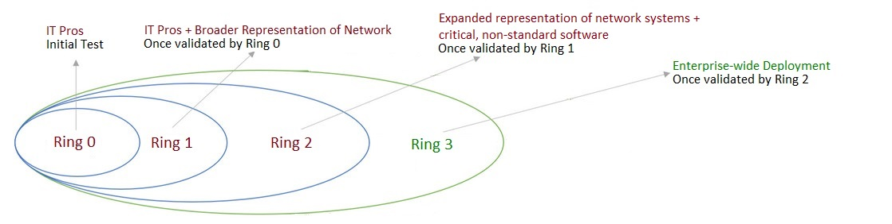
- Preparing for Deployments
Since the new update methodology requires very little (if any) changes to existing SCCM configurations, only one or two adjustments may be needed in order to ensure that the new updates can be downloaded and deployed.
  - Software Update Point
The security-only updates and monthly rollups are both classified as Security Updates, so this classification must be selected. Organizations that are already using Configuration Manager for update management will already have it selected.
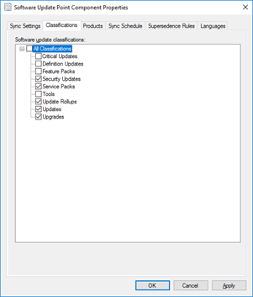
  - Automatic Deployment Rules (ADRs)
ADRs that include the Security Updates classification will approve both the security-only update release and the monthly rollup for deployment. Since the monthly rollup contains all of the fixes in the security-only update, or if the organization does not want to deploy non-security updates, administrators should use one of the following recommendations to prevent the deployment of both update types.
- Use manual approval
- Create a filter based off of the title of the update to ensure that both are not deployed. Examples of title search strings: “Security Only” or “Quality Rollup”.
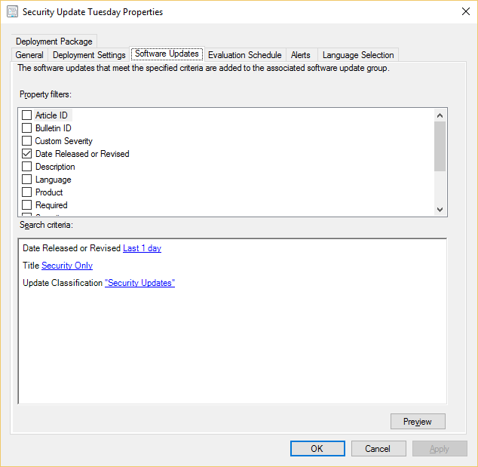
  - Behavior of Deploying Both Update Types
Regardless of whether or not the security-only update or monthly rollup installs on devices first, as long as one of them installs, the devices will have the needed security fixes that were released that month.
The installation behavior is what changes depending on the order of deployment.
- If the monthly rollup installs first, the entire content of the security-only update will already be installed so it will no longer be applicable.
- If the security-only update installs first, any non-security fixes or older security fixes that are needed by the PC will then be installed by the monthly rollup.
- Deploying Updates (Ringed Approach)
The overall goal of this guide is to provide Configuration Manger administrators an update-servicing template that is effective, but also has a low administrative burden.
This is accomplished using the ringed approach because it takes little time to setup, and it is easily repeatable each month as new updates are released.
NOTE: This document assumes that the reader already has a firm understanding of the fundamental processes and components of System Center Configuration Manager such as creating/managing device collections and software update deployments. As a result, step-by-step guidance for creating and managing objects such as these is out of the scope of the document.
  - Collection Configuration
Refer to the guidance and table below for your organization’s collection configuration standards for ringed deployments.
Ring 0:
- Newly released updates/rollups are initially deployed to this collection.
- Collection should only contain devices used by IT professionals and other expert users who are capable of providing the information and detail required to effectively troubleshoot issues resulting from an update deployment.
Ring 1:
- Once integrity of the Ring 0 systems is verified, this collection is targeted with the same update/rollup.
- Collection should contain additional IT professionals’ devices as well as a broader mix of general hardware/software platforms found on the network.
Ring 2:
- The final pilot deployment before full enterprise-wide distribution.
- Collection should contain more systems than the Ring 1 collection, and represent the hardware and software that exists on the network as closely as possible. This should also include a few systems installed with any non-standard software that is critical to the organization.
Ring 3:
- The final, enterprise-wide production deployment of the update/rollup.

Adjustment to the collections’ memberships may be necessary after the first one or two deployment cycles, but overall, they should require little modification/management as the process matures.
Use the table below to input the customized collection settings for your organization.
Collection Name and Description | Properties
 | Limiting Collection | Membership Rule(s) | Maintenance Window (if applicable)  [enter values for each setting below]
Update Servicing - Ring 0  Windows update target collection containing only IT staff (“expert” users) devices | [enter limiting collection name here] | Direct Rules:  [list direct rules here] | Name:
 |  |  | Date:
 |  |  | Start:
 |  | Query Syntax:  [paste query syntax here] | End:
 |  |  | Recurrence:
 |  |  | Applied to:
Update Servicing - Ring 1  Initial, limited pilot test collection containing a broader mix of h/w and s/w platforms | [enter limiting collection name here] | Direct Rules:  [list direct rules here] | Name:
 |  |  | Date:
 |  |  | Start:
 |  | Query Syntax:  [paste query syntax here] | End:
 |  |  | Recurrence:
 |  |  | Applied to:
Update Servicing - Ring 2  Expanded pilot collection containing larger number of systems including those with critical, non-standard software | [enter limiting collection name here] | Direct Rules:  [list direct rules here] | Name:
 |  |  | Date:
 |  |  | Start:
 |  | Query Syntax:  [paste query syntax here] | End:
 |  |  | Recurrence:
 |  |  | Applied to:
Update Servicing - Ring 3  Enterprise-wide deployment collection | [enter limiting collection name here] | Direct Rules:  [list direct rules here] | Name:
 |  |  | Date:
 |  |  | Start:
 |  | Query Syntax:  [paste query syntax here] | End:
 |  |  | Recurrence:
 |  |  | Applied to:
Table 3 – Collection Configuration
  - Deployment Configuration
In order to limit the administrative burden of managing the deployments, the settings for each deployment (regardless of the ring being targeted) should be consistent. Refer to the table below for your organization’s standard configuration for update deployments.
Using the ringed deployment approach, administrators have some flexibility for managing the deployments.
- Option 1: Create a separate (new) deployment for each ring as testing progresses through the cycle.
- Option 2: Use the same deployment for all rings, and just change the target collection (ring) and schedule settings accordingly as testing progresses through the cycle.

NOTE: Since security-only updates do not contain fixes from previous months, it is recommended to retain the earlier deployments for a period of time to ensure compliance. At a minimum, the security-only updates should remain deployed until they are included in the organization’s OS baseline image.
This isn’t necessary with the monthly rollups since they are cumulative.

Another recommendation is to append the target collection’s ring number and applicable release month and year of the update/rollup to the name of the deployment.
Adjustment of the deployment(s) settings may be necessary after the first one or two deployment cycles, but overall, they should require little modification/management as the process matures.
Use the table below to input the customized deployment settings for your organization.
Tab | Name | Setting
General | Deployment Name | Example: Update Servicing – Ring # - mmyy  NOTE: Append the name with the ring number targeted as well as the applicable month/year of the update release
 | Software Update/Group | [select the update/rollup for current month]
 | Collection | [select the collection (ring) that corresponds to the deployment]
Deployment Settings | Type of Deployment | [Required or Available]
 | Detail Level | [select desired status message detail]
Scheduling | Schedule Evaluation | [UTC or Client local time]
 | Software Available Time | [configure a specific day/time according to SLAs, maintenance windows or other rules that govern configuration changes w/in the organization]
 | Installation Deadline | [configure a specific day/time according to SLAs, maintenance windows or other rules that govern configuration changes w/in the organization]
User Experience | User Visual Experience | [select what’s available to the user]
 | Deadline Behavior | [Software updates installation or System restart]
 | Device Restart Behavior | [Servers, Workstations or both]
 | Write filter handling of Windows Embedded Devices | [Selected or unselected]
 | Software updates deployment re-evaluation behavior | [Selected or unselected]
Download Settings | Slow/unreliable boundary options | [Don’t install or Download and install]
 | Fallback options | [Don’t install or Download and install]
 | Client content sharing on same subnet | [Selected or unselected]
 | Download from Microsoft Update if content unavailable | [Selected or unselected]
 | Download on metered Internet connection | [Selected or unselected]
Table 4 – Deployment Configuration
- Issues Caused by a Deployment
If any issues are encountered during the deployment of an update or rollup, it is critical that the deployment is stopped/paused at the current ring level so that higher levels (greater numbers of systems) are also not affected.
The troubleshooting process will determine whether or not the issue is in fact the result of the update installation, and once resolved, deployments should resume at the ring level in which the issue first occurred.
General courses of action that can be taken, depending on the severity and/or specifics of the problem can include:
- Rolling back the update/rollup on affected machines.
- Installation of fix that was created to resolve the issue observed.
- Working with the publisher for an affected application.
For detailed troubleshooting guidance, refer to the applicable external links in the References section below.
- References
TechNet Blog – Michael Niehaus – More on Windows 7 and Windows 8.1 Servicing Changes
https://blogs.technet.microsoft.com/windowsitpro/2016/10/07/more-on-windows-7-and-windows-8-1-servicing-changes/

.NET Blog - .NET Framework Monthly Rollups Explained
https://blogs.msdn.microsoft.com/dotnet/2016/10/11/net-framework-monthly-rollups-explained/

WSUS Troubleshooting Survival Guide
http://social.technet.microsoft.com/wiki/contents/articles/2491.wsus-troubleshooting-survival-guide.aspx

How to Obtain Error Code Descriptions in Configuration Manager 2007
http://support.microsoft.com/kb/944375/en-us
NOTE: While this article references SCCM 2007, it still applies to later versions.

Translating Error Codes for Windows and Configuration Manager
https://smsagent.wordpress.com/2015/06/25/translating-error-codes-for-windows-and-configuration-manager/comment-page-1/

Windows Installer Error Code Descriptions
http://msdn.microsoft.com/en-us/library/aa376931(v=vs.85).aspx

Windows Update Error Code Descriptions
http://support.microsoft.com/kb/938205/en-us

